**Install NodeJS and NPM using nvm**

Install node version manager (nvm) by typing the following at the command line.

*curl -o-*[*https://raw.githubusercontent.com/nvm-sh/nvm/v0.34.0/install.sh*](https://raw.githubusercontent.com/nvm-sh/nvm/v0.34.0/install.sh)*| bash*

Activate nvm by typing the following at the command line.

*. ~/.nvm/nvm.sh*

Use nvm to install the latest version of Node.js by typing the following at the command line.

*nvm install node*

Test that *node* and *npm* are installed and running correctly by typing the following at the terminal:

*node -v*

*npm -v*

**Install Git and clone repository from GitHub**

To install git, run below commands in the terminal window:

*sudo yum update -y  
sudo yum install git -y*

Just to verify if system has git installed or not, please run below command in terminal:

*git — version*

This command will print the git version in the terminal.

Run below command to clone the code repository from Github:

*git clone*[*https://github.com/sumant-mishra/node-app.git*](https://github.com/sumant-mishra/node-app.git)

This will create a folder with name node-app.

**Install dependencies**

Now, move to the folder node-app by running below command in the terminal window:

*cd node-app*

If you check the list of folders using ls command, the current folder structure does not contain the *node_modules* folder. This folder will be created automatically after installing the dependencies. To install dependencies, run below command in the terminal:

*npm install*

**Start the application**

To start the application, run the below command in the terminal:

*node index.js*

If the server runs successfully, then it should print a message with the port number in the terminal window as shown below:

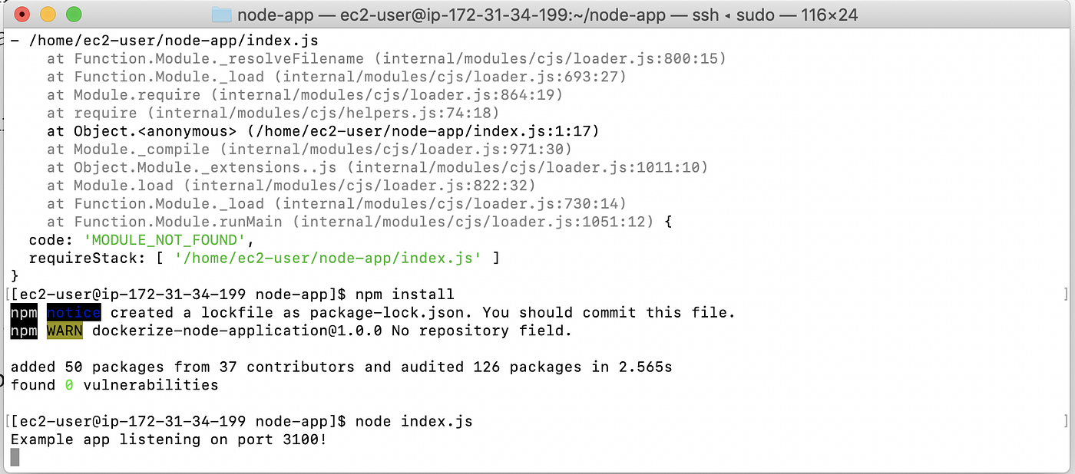

**Configure security group to access via public URL**

By default, nobody can access the application without configuring the Inbound traffic configurations for the EC2 instance. To configure Inbound traffic for the EC2 instance, follow the below steps:

Select the EC2 Instance and click on the security group link in the Description section.

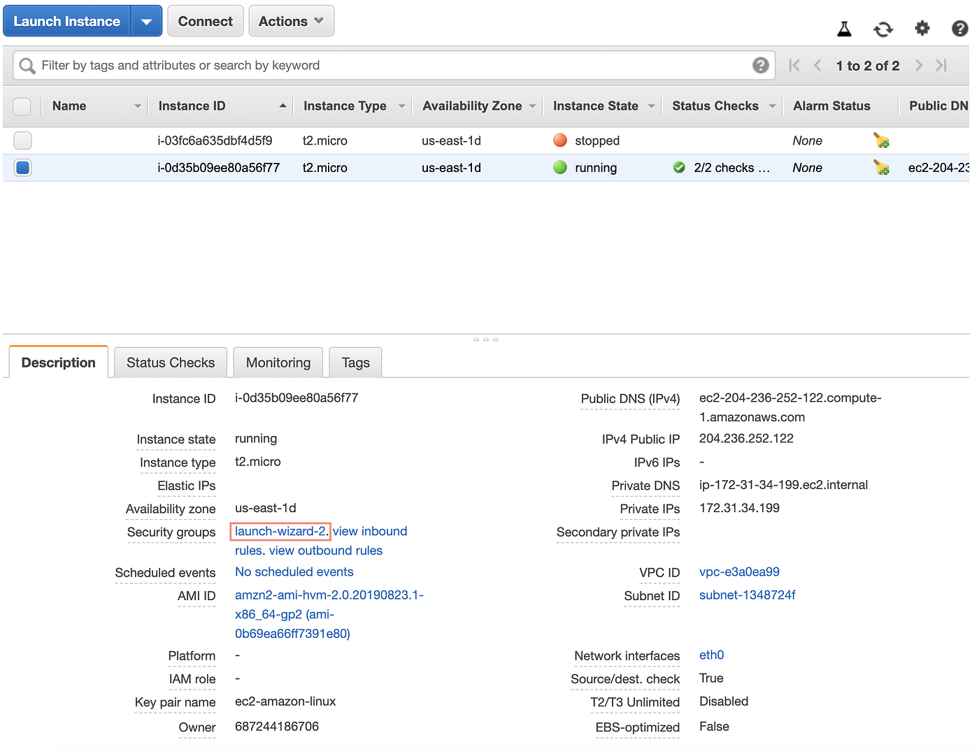

By clicking the security group it will open the Security Group section. Here, we can configure Inbound and Outbound traffic properties. To make our application accessible from anywhere, click on the Inbound tab.

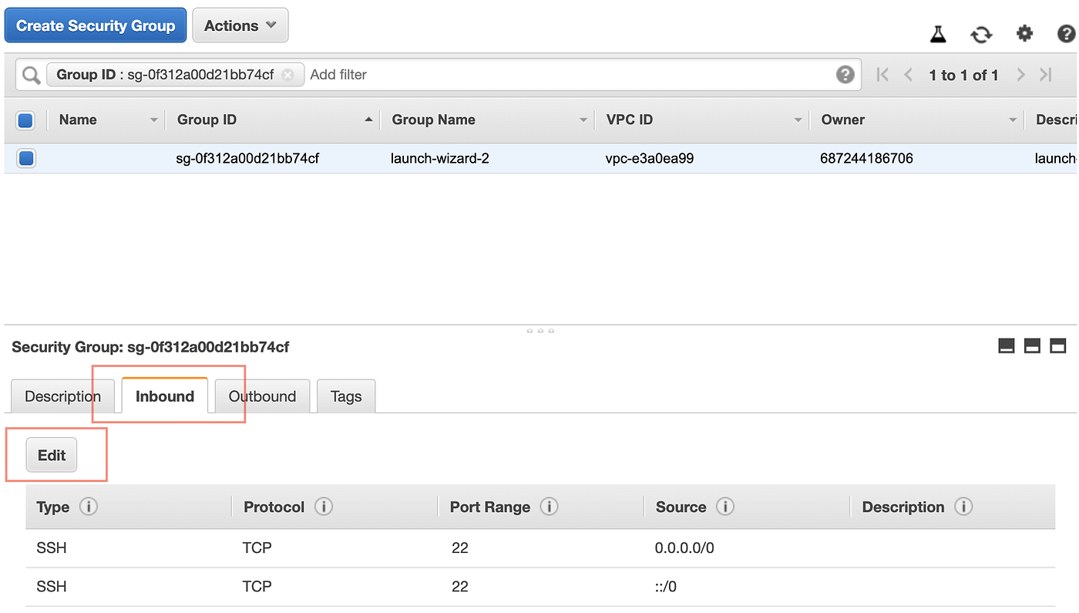

By clicking on the Edit button available in the Inbound tab, it will open Edit Inbound rules popup. By default, it will show SSH configurations. Since our application is configured for port number 3100, we need to add a new rule “Custom TCP Rule”. Enter port range as 3100 and select Source as “Anywhere”. After saving the changed rules, it will allow us to access our application from anywhere.

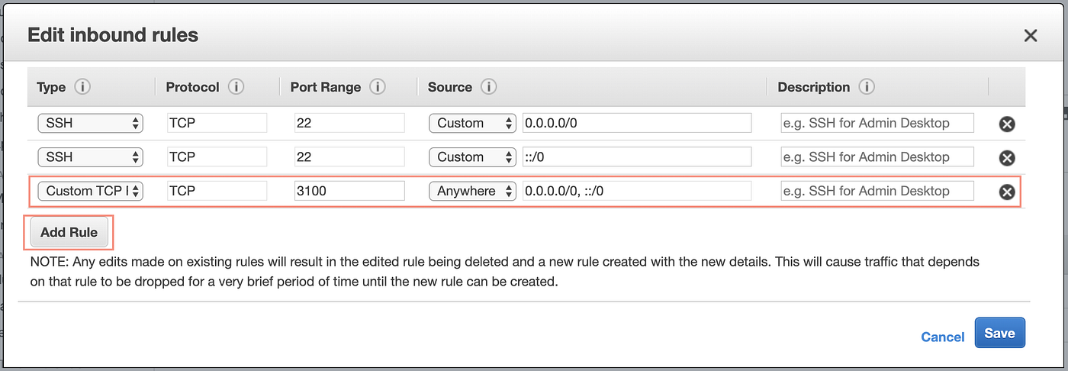

**Access the application in browser**



Photo by [Braden Collum](https://unsplash.com/@bradencollum?utm_source=medium&utm_medium=referral) on [Unsplash](https://unsplash.com?utm_source=medium&utm_medium=referral)

Now, we are ready and can access our application using both Public IP or Public DNS and port 3100 in browsers. For example,

*ec2–204–236–252–122.compute-1.amazonaws.com:3100*

or

*204.236.252.122: 3100*